SPRING CORE_MAVEN
Exercise 1: Configuring a Basic Spring Application
ApplicationContext.xml

<?xml version="1.0" encoding="UTF-8"?>

<beans xmlns="http://www.springframework.org/schema/beans"
xmlns:xsi="http://www.w3.org/2001/XMLSchema-instance"
xsi:schemaLocation="
http://www.springframework.org/schema/beans
https://www.springframework.org/schema/beans/spring-beans.xsd">

<bean id="bookService"
class="org.example.service.BookService"/>

<bean id="bookRepository"
class="org.example.repository.BookRepository"/>

</beans>
POM.XML
<project xmlns="http://maven.apache.org/POM/4.0.0"
xmlns:xsi="http://www.w3.org/2001/XMLSchema-instance"
xsi:schemaLocation="http://maven.apache.org/POM/4.0.0
http://maven.apache.org/xsd/maven-4.0.0.xsd">

<modelVersion>4.0.0</modelVersion>

<groupId>org.example</groupId>
<artifactId>LibraryManagement</artifactId>
<version>1.0-SNAPSHOT</version>

<dependencies>

<!-- Spring Core -->
<dependency>
<groupId>org.springframework</groupId>
<artifactId>spring-context</artifactId>
<version>5.3.30</version>
</dependency>

</dependencies>

</project>

BookRepository.java
package org.example.repository;

public class BookRepository {

public void displayRepository() {
System.out.println("Book Repository Bean Created");
}
}
BookService.java
package org.example.service;

public class BookService {

public void displayService() {
System.out.println("Book Service Bean Created");
}
}
LibraryManagementApplication.java
package org.example;

import org.example.repository.BookRepository;
import org.example.service.BookService;
import org.springframework.context.ApplicationContext;
import org.springframework.context.support.ClassPathXmlApplicationContext;

public class LibraryManagementApplication {

public static void main(String[] args) {

ApplicationContext context =
new ClassPathXmlApplicationContext("applicationContext.xml");

BookService service =
(BookService) context.getBean("bookService");

BookRepository repository =
(BookRepository) context.getBean("bookRepository");

service.displayService();
repository.displayRepository();
}
}

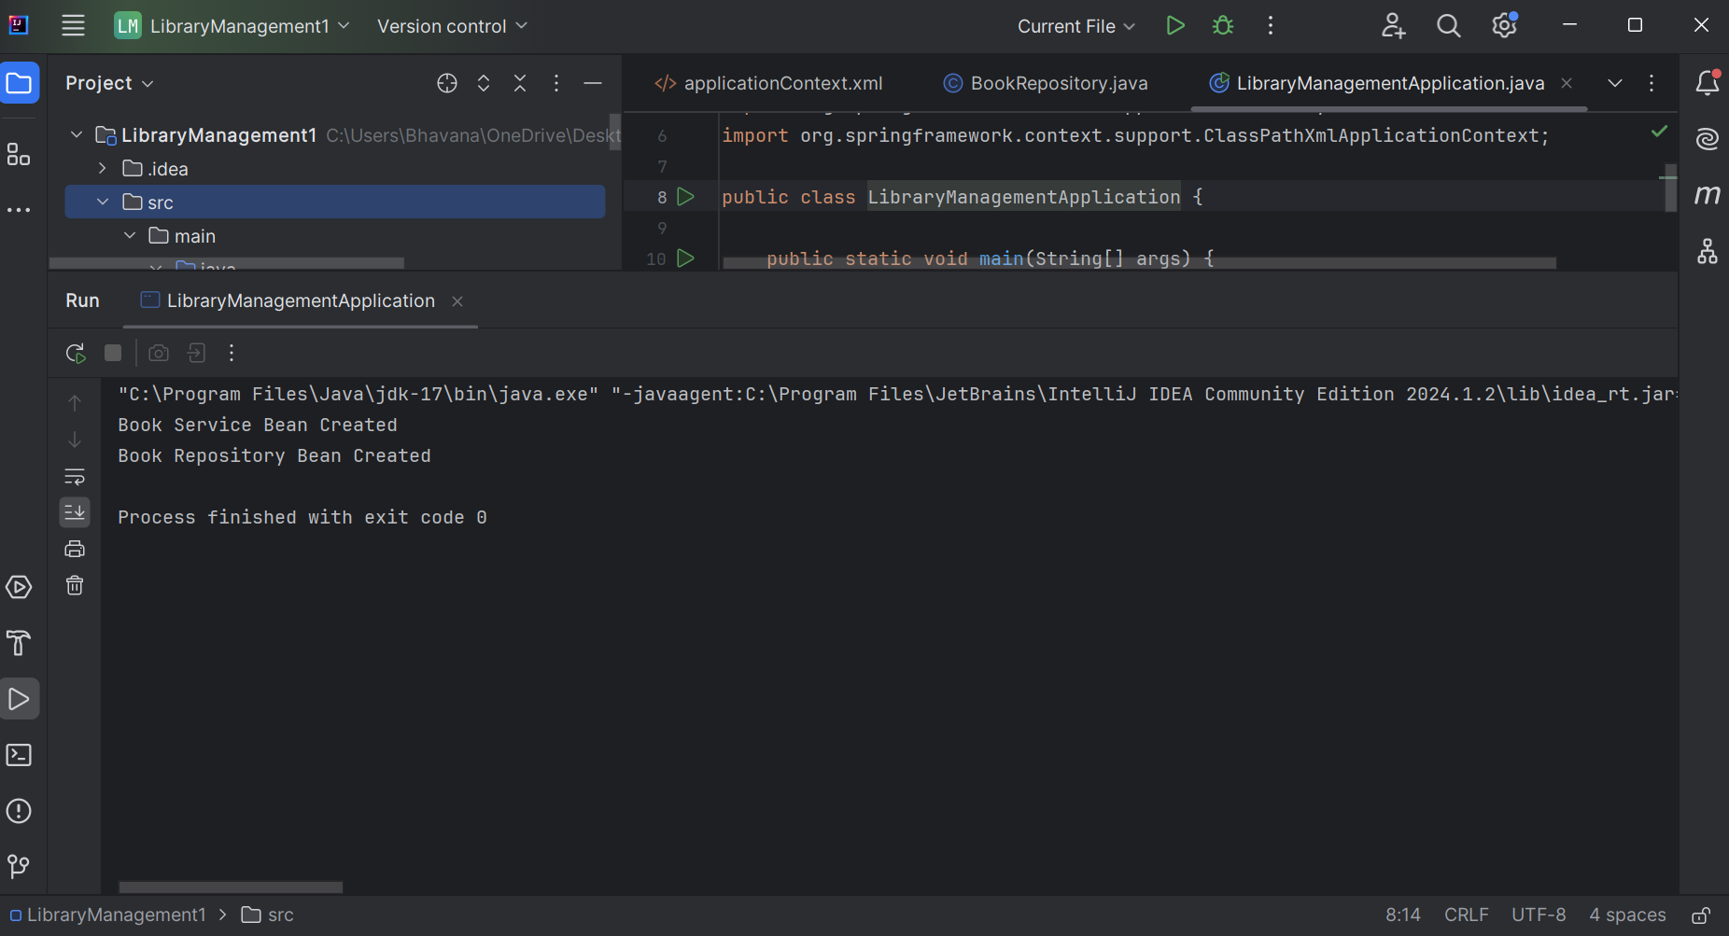

Exercise 2: Implementing Dependency Injection
AppplicationContext.xml
<?xml version="1.0" encoding="UTF-8"?>

<beans xmlns="http://www.springframework.org/schema/beans"
xmlns:xsi="http://www.w3.org/2001/XMLSchema-instance"
xsi:schemaLocation="
http://www.springframework.org/schema/beans
https://www.springframework.org/schema/beans/spring-beans.xsd">

<bean id="bookRepository"
class="org.example.repository.BookRepository"/>

<bean id="bookService"
class="org.example.service.BookService">

<property name="bookRepository"
ref="bookRepository"/>

</bean>

</beans>

POM.XML
<project xmlns="http://maven.apache.org/POM/4.0.0"
xmlns:xsi="http://www.w3.org/2001/XMLSchema-instance"
xsi:schemaLocation="http://maven.apache.org/POM/4.0.0
http://maven.apache.org/xsd/maven-4.0.0.xsd">

<modelVersion>4.0.0</modelVersion>

<groupId>org.example</groupId>
<artifactId>LibraryManagement</artifactId>
<version>1.0-SNAPSHOT</version>

<dependencies>

<!-- Spring Core -->
<dependency>
<groupId>org.springframework</groupId>
<artifactId>spring-context</artifactId>
<version>5.3.30</version>
</dependency>

</dependencies>

</project>

BookRepository.java
package org.example.repository;

public class BookRepository {

public void displayBook() {
System.out.println("Book Repository: Displaying book details");
}
}
BookService.java
package org.example.service;

import org.example.repository.BookRepository;

public class BookService {

private BookRepository bookRepository;

// Setter Injection
public void setBookRepository(BookRepository bookRepository) {
this.bookRepository = bookRepository;
}

public void displayService() {
System.out.println("Book Service: Managing books");
bookRepository.displayBook();
}
}
LibraryManagementApplication.java
package org.example;

import org.example.service.BookService;
import org.springframework.context.ApplicationContext;
import org.springframework.context.support.ClassPathXmlApplicationContext;

public class LibraryManagementApplication {

public static void main(String[] args) {

ApplicationContext context =
new ClassPathXmlApplicationContext("applicationContext.xml");

BookService service =
(BookService) context.getBean("bookService");

service.displayService();
}
}
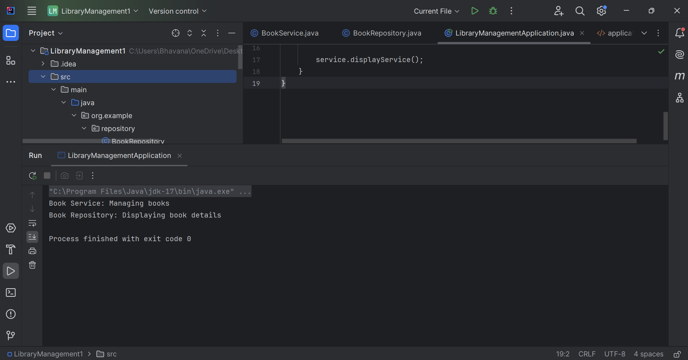

Exercise 4: Creating and Configuring a Maven Project
AppplicationContext.xml
<?xml version="1.0" encoding="UTF-8"?>

<beans xmlns="http://www.springframework.org/schema/beans"
xmlns:xsi="http://www.w3.org/2001/XMLSchema-instance"
xsi:schemaLocation="
http://www.springframework.org/schema/beans
https://www.springframework.org/schema/beans/spring-beans.xsd">

<bean id="bookRepository"
class="org.example.repository.BookRepository"/>

<bean id="bookService"
class="org.example.service.BookService">

<property name="bookRepository"
ref="bookRepository"/>

</bean>

</beans>

POM.XML
<project xmlns="http://maven.apache.org/POM/4.0.0"
xmlns:xsi="http://www.w3.org/2001/XMLSchema-instance"
xsi:schemaLocation="http://maven.apache.org/POM/4.0.0
https://maven.apache.org/xsd/maven-4.0.0.xsd">

<modelVersion>4.0.0</modelVersion>

<groupId>org.example</groupId>
<artifactId>LibraryManagement</artifactId>
<version>1.0-SNAPSHOT</version>

<dependencies>

<!-- Spring Context -->
<dependency>
<groupId>org.springframework</groupId>
<artifactId>spring-context</artifactId>
<version>5.3.30</version>
</dependency>

<!-- Spring AOP -->
<dependency>
<groupId>org.springframework</groupId>
<artifactId>spring-aop</artifactId>
<version>5.3.30</version>
</dependency>

<!-- Spring Web MVC -->
<dependency>
<groupId>org.springframework</groupId>
<artifactId>spring-webmvc</artifactId>
<version>5.3.30</version>
</dependency>

</dependencies>

<build>
<plugins>

<plugin>
<groupId>org.apache.maven.plugins</groupId>
<artifactId>maven-compiler-plugin</artifactId>
<version>3.11.0</version>

<configuration>
<source>1.8</source>
<target>1.8</target>
</configuration>

</plugin>

</plugins>
</build>

</project>

BookRepository.java
package org.example.repository;

public class BookRepository {

public void displayBook() {
System.out.println("Book Repository: Displaying book details");
}
}
BookService.java
package org.example.service;

import org.example.repository.BookRepository;

public class BookService {

private BookRepository bookRepository;

// Setter Injection
public void setBookRepository(BookRepository bookRepository) {
this.bookRepository = bookRepository;
}

public void displayService() {
System.out.println("Book Service: Managing books");
bookRepository.displayBook();
}
}
LibraryManagementApplication.java
package org.example;

import org.example.service.BookService;
import org.springframework.context.ApplicationContext;
import org.springframework.context.support.ClassPathXmlApplicationContext;

public class LibraryManagementApplication {

public static void main(String[] args) {

ApplicationContext context =
new ClassPathXmlApplicationContext("applicationContext.xml");

BookService service =
(BookService) context.getBean("bookService");

service.displayService();
}
}

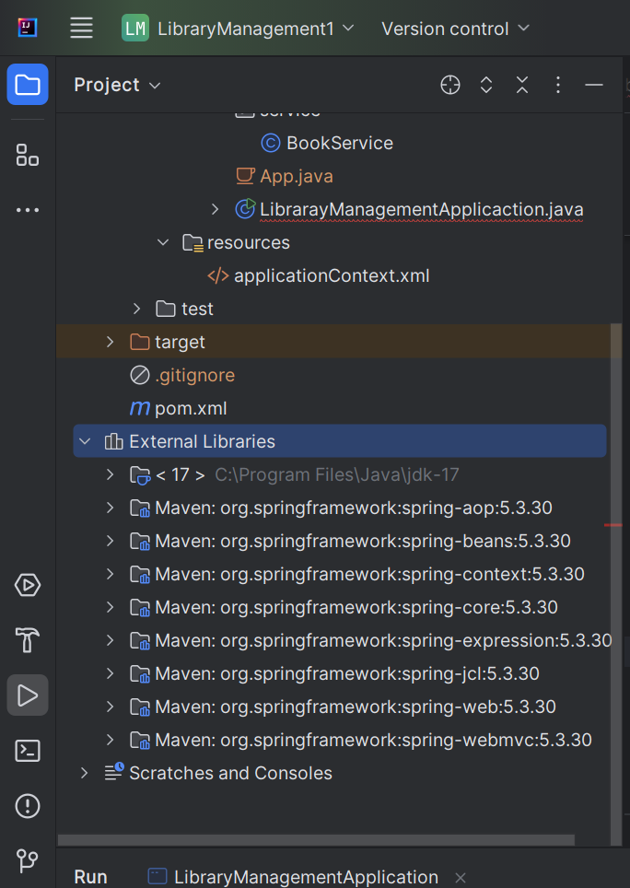

Additional HandsOn:
Exercise 5: Configuring the Spring IoC Container
ApplicationContext.xml
<?xml version="1.0" encoding="UTF-8"?>

<beans xmlns="http://www.springframework.org/schema/beans"
xmlns:xsi="http://www.w3.org/2001/XMLSchema-instance"
xsi:schemaLocation="
http://www.springframework.org/schema/beans
https://www.springframework.org/schema/beans/spring-beans.xsd">

<bean id="bookRepository"
class="org.example.repository.BookRepository"/>

<bean id="bookService"
class="org.example.service.BookService">

<property name="bookRepository"
ref="bookRepository"/>

</bean>

</beans>

BookRepository.java
package org.example.repository;

public class BookRepository {

public void displayBook() {
System.out.println("Book Repository: Displaying book details");
}
}

BookService.java
package org.example.service;

import org.example.repository.BookRepository;

public class BookService {

private BookRepository bookRepository;

// Setter Injection
public void setBookRepository(BookRepository bookRepository) {
this.bookRepository = bookRepository;
}

public void displayService() {
System.out.println("Book Service: Managing books");
bookRepository.displayBook();
}
}
Pom.xml
<project xmlns="http://maven.apache.org/POM/4.0.0"
xmlns:xsi="http://www.w3.org/2001/XMLSchema-instance"
xsi:schemaLocation="http://maven.apache.org/POM/4.0.0
https://maven.apache.org/xsd/maven-4.0.0.xsd">

<modelVersion>4.0.0</modelVersion>

<groupId>org.example</groupId>
<artifactId>LibraryManagement</artifactId>
<version>1.0-SNAPSHOT</version>

<properties>
<maven.compiler.source>1.8</maven.compiler.source>
<maven.compiler.target>1.8</maven.compiler.target>
<project.build.sourceEncoding>UTF-8</project.build.sourceEncoding>
</properties>

<dependencies>

<!-- Spring Context -->
<dependency>
<groupId>org.springframework</groupId>
<artifactId>spring-context</artifactId>
<version>5.3.30</version>
</dependency>

<!-- Spring AOP -->
<dependency>
<groupId>org.springframework</groupId>
<artifactId>spring-aop</artifactId>
<version>5.3.30</version>
</dependency>

<!-- Spring Web MVC -->
<dependency>
<groupId>org.springframework</groupId>
<artifactId>spring-webmvc</artifactId>
<version>5.3.30</version>
</dependency>

</dependencies>

<build>
<plugins>

<plugin>
<groupId>org.apache.maven.plugins</groupId>
<artifactId>maven-compiler-plugin</artifactId>
<version>3.11.0</version>

<configuration>
<source>1.8</source>
<target>1.8</target>
</configuration>

</plugin>

</plugins>
</build>

</project>

LibraryManagementApplication.java
package org.example;

import org.example.service.BookService;
import org.springframework.context.ApplicationContext;
import org.springframework.context.support.ClassPathXmlApplicationContext;

public class LibraryManagementApplication {

public static void main(String[] args) {

ApplicationContext context =
new ClassPathXmlApplicationContext("applicationContext.xml");

BookService service =
(BookService) context.getBean("bookService");

service.displayService();
}
}

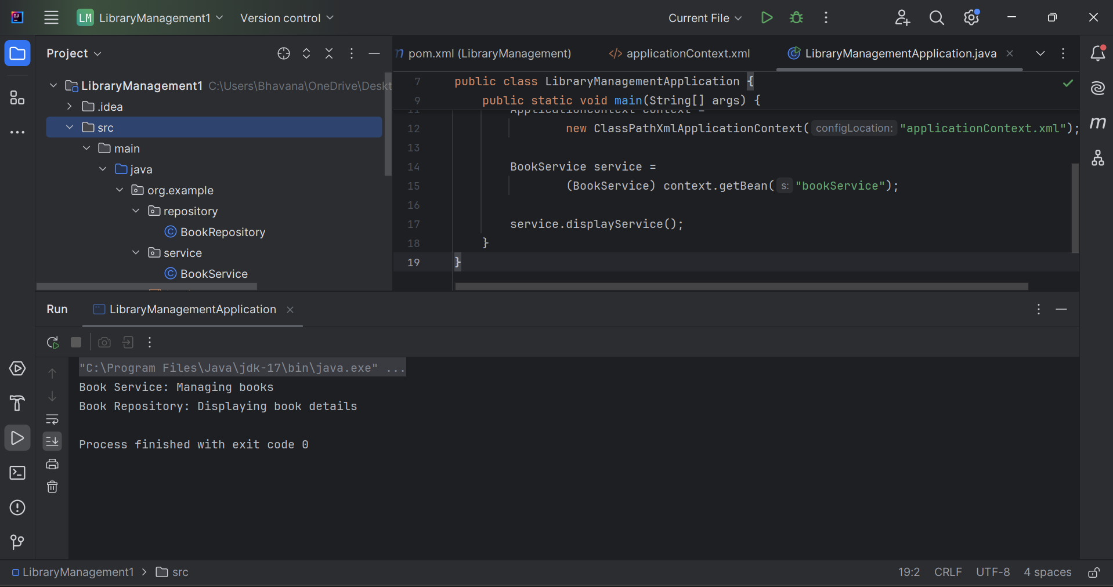

Exercise 7: Implementing Constructor and Setter Injection
applicationContext.xml
<?xml version="1.0" encoding="UTF-8"?>

<beans xmlns="http://www.springframework.org/schema/beans"
xmlns:xsi="http://www.w3.org/2001/XMLSchema-instance"
xsi:schemaLocation="
http://www.springframework.org/schema/beans
https://www.springframework.org/schema/beans/spring-beans.xsd">

<bean id="bookRepository"
class="org.example.repository.BookRepository"/>

<bean id="bookService"
class="org.example.service.BookService">

<!-- Constructor Injection -->
<constructor-arg ref="bookRepository"/>

<!-- Setter Injection -->
<property name="bookRepository"
ref="bookRepository"/>

</bean>

</beans>
BookRepository.java
package org.example.repository;

public class BookRepository {

public void displayBook() {
System.out.println("Book Repository: Displaying book details");
}
}
BookService.java
package org.example.service;

import org.example.repository.BookRepository;

public class BookService {

private BookRepository bookRepository;

// Constructor Injection
public BookService(BookRepository bookRepository) {
this.bookRepository = bookRepository;
System.out.println("Constructor Injection Executed");
}

// Setter Injection
public void setBookRepository(BookRepository bookRepository) {
this.bookRepository = bookRepository;
System.out.println("Setter Injection Executed");
}

public void displayService() {
System.out.println("Book Service: Managing books");
bookRepository.displayBook();
}
}
POM.XML
<project xmlns="http://maven.apache.org/POM/4.0.0"
xmlns:xsi="http://www.w3.org/2001/XMLSchema-instance"
xsi:schemaLocation="http://maven.apache.org/POM/4.0.0
https://maven.apache.org/xsd/maven-4.0.0.xsd">

<modelVersion>4.0.0</modelVersion>

<groupId>org.example</groupId>
<artifactId>LibraryManagement</artifactId>
<version>1.0-SNAPSHOT</version>

<properties>
<maven.compiler.source>1.8</maven.compiler.source>
<maven.compiler.target>1.8</maven.compiler.target>
<project.build.sourceEncoding>UTF-8</project.build.sourceEncoding>
</properties>

<dependencies>

<!-- Spring Context -->
<dependency>
<groupId>org.springframework</groupId>
<artifactId>spring-context</artifactId>
<version>5.3.30</version>
</dependency>

<!-- Spring AOP -->
<dependency>
<groupId>org.springframework</groupId>
<artifactId>spring-aop</artifactId>
<version>5.3.30</version>
</dependency>

<!-- Spring Web MVC -->
<dependency>
<groupId>org.springframework</groupId>
<artifactId>spring-webmvc</artifactId>
<version>5.3.30</version>
</dependency>

</dependencies>

<build>
<plugins>

<plugin>
<groupId>org.apache.maven.plugins</groupId>
<artifactId>maven-compiler-plugin</artifactId>
<version>3.11.0</version>

<configuration>
<source>1.8</source>
<target>1.8</target>
</configuration>

</plugin>

</plugins>
</build>

</project>
LibraryManagementApplication.java
package org.example;

import org.example.service.BookService;
import org.springframework.context.ApplicationContext;
import org.springframework.context.support.ClassPathXmlApplicationContext;

public class LibraryManagementApplication {

public static void main(String[] args) {

ApplicationContext context =
new ClassPathXmlApplicationContext("applicationContext.xml");

BookService service =
(BookService) context.getBean("bookService");

service.displayService();
}
}

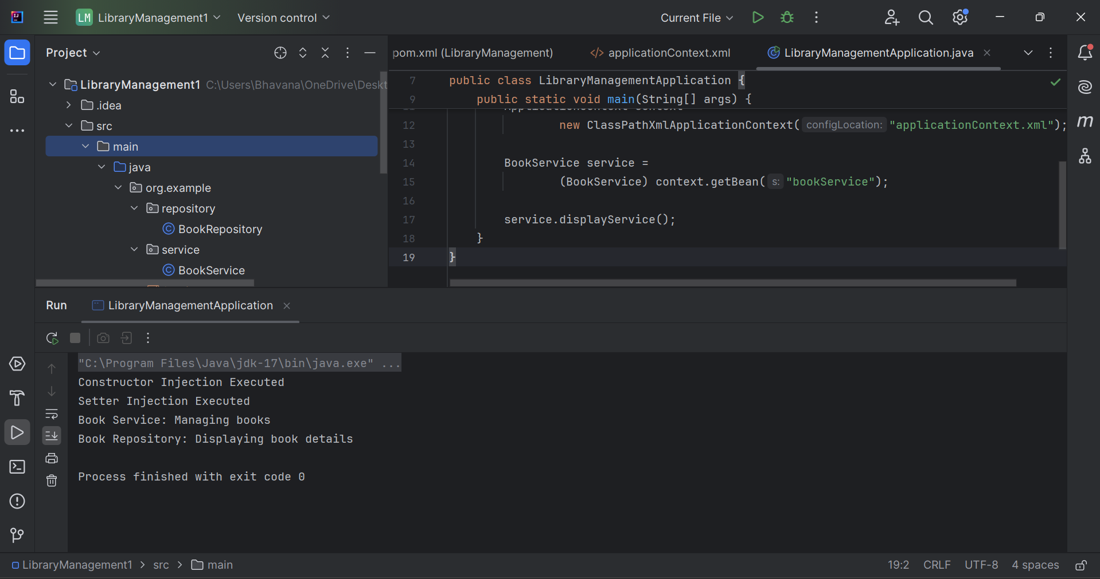

Exercise 9: Creating a Spring Boot Application
Book.java
package com.library.LibraryManagement.entity;

import jakarta.persistence.Entity;
import jakarta.persistence.Id;

@Entity
public class Book {

@Id
private Long id;
private String title;
private String author;

public Book() {}

public Book(Long id, String title, String author) {
this.id = id;
this.title = title;
this.author = author;
}

public Long getId() { return id; }
public void setId(Long id) { this.id = id; }

public String getTitle() { return title; }
public void setTitle(String title) { this.title = title; }

public String getAuthor() { return author; }
public void setAuthor(String author) { this.author = author; }
}
BookRepository.java
package com.library.LibraryManagement.repository;

import com.library.LibraryManagement.entity.Book;
import org.springframework.data.jpa.repository.JpaRepository;

public interface BookRepository extends JpaRepository<Book, Long> {
}

BookController.java
package com.library.LibraryManagement.controller;

import com.library.LibraryManagement.entity.Book;
import com.library.LibraryManagement.repository.BookRepository;
import org.springframework.web.bind.annotation.*;

import java.util.List;

@RestController
@RequestMapping("/books")
public class BookController {

private final BookRepository repository;

public BookController(BookRepository repository) {
this.repository = repository;
}

@PostMapping
public Book addBook(@RequestBody Book book) {
return repository.save(book);
}

@GetMapping
public List<Book> getBooks() {
return repository.findAll();
}
}

Application.properties
spring.datasource.url=jdbc:h2:mem:librarydb
spring.datasource.driverClassName=org.h2.Driver
spring.datasource.username=sa
spring.datasource.password=

spring.jpa.hibernate.ddl-auto=update

spring.h2.console.enabled=true
LibraryManagementApplication.java
package com.library.LibraryManagement;
import org.springframework.boot.SpringApplication;
import org.springframework.boot.autoconfigure.SpringBootApplication;
@SpringBootApplication
public class LibraryManagementApplication {
public static void main(String[] args) {
SpringApplication.run(LibraryManagementApplication.class, args);
}
}

